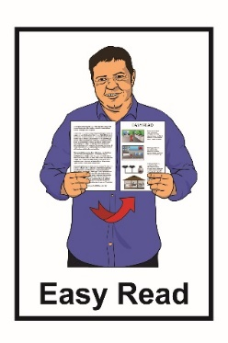

What to do if you think you have COVID-19

16 March 2020 update

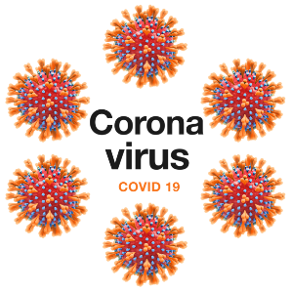
People who are sick with COVID-19 may:

- have a cough
- have a fever - this is when you
get really hot and have a temperature of 38 degrees or more

- find it hard to breathe.

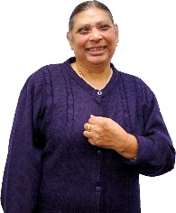
Some people with COVID-19 may not feel sick at all.

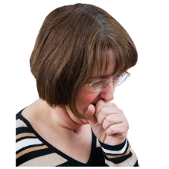
But they can still pass the virus to another person.

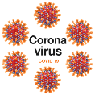
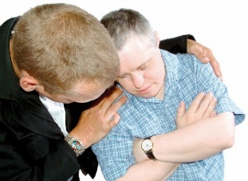
It is important you know what to do if you:

- have been in close contact with someone in the last 14 days who has been told they have COVID-19

- are waiting for your COVID-19 test results.

There are 2 things you need to do if you think you have COVID-19:
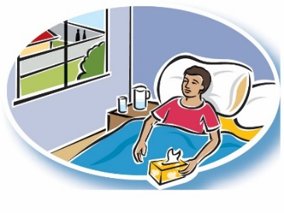

- You need to stay at home and self-isolate.

Self-isolate means not being in places for 14 days where you could give the COVID-19 virus to other people.

There is an Easy Read factsheet called COVID-19 and self-isolation.

See page 5 for more information about this factsheet.

- You need to call Healthline on:
0800 358 5453

It will not cost you any money to call Healthline.

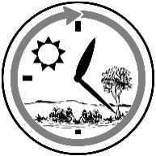
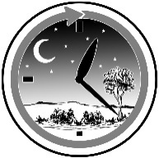
Healthline is open all the time – day and night.

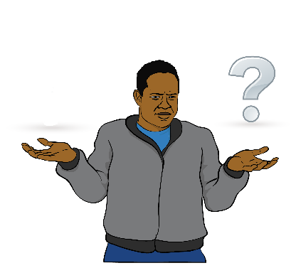
If you are not sure if you should self-isolate you can call Healthline on:

0800 358 5453

If you think you might have COVID-19 it is important that you do not go to:

- your Doctor

- the hospital.

Going to see your Doctor or hospital could give the COVID-19 virus to other people.

Instead call Healthline as they will tell you what to do if you need to be tested for COVID-19.

Where to find more Easy Read
information about COVID-19

There are some Easy Read factsheets:

- What is coronavirus and COVID-19?

- COVID-19 information for people coming into New Zealand from overseas

- COVID-19 and self-isolation.

You can find these Easy Read factsheets on the Ministry of Health website:
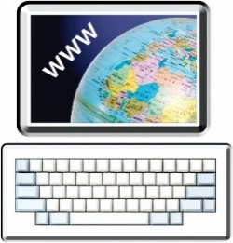
www.health.govt.nz/our-work/diseases-and-conditions/ covid-19-novel-coronavirus

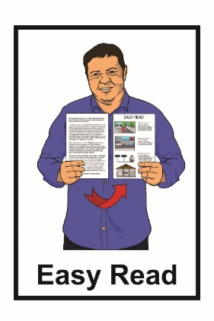
This information has been translated into Easy Read by the Make It Easy service of People First New Zealand Inc. Ngā Tāngata Tuatahi.

The ideas in this document are not the ideas of People First New Zealand Ngā Tāngata Tuatahi.

Make It Easy uses images from:
- Changepeople.org

- Photosymbols.com

- Sam Corliss

- Steve Bolton

