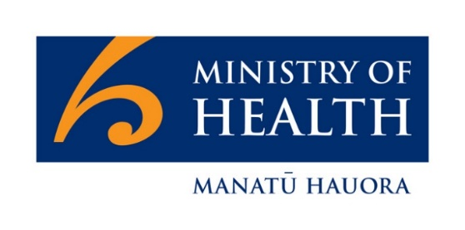
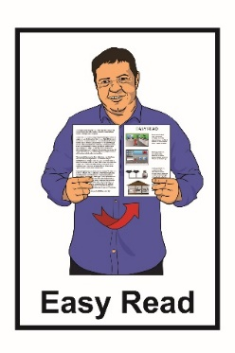

What is coronavirus and COVID-19?

16 March 2020 update

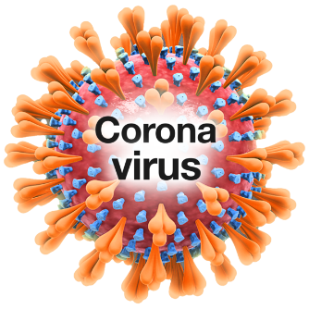
Coronaviruses are a big group of viruses that can make people and animals sick.

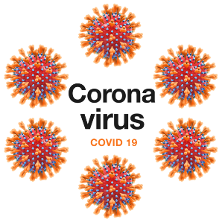
A virus is something that can make people sick.

1 type of Coronavirus that can make people to sick is called COVID-19.

COVID-19 can pass from person to person.

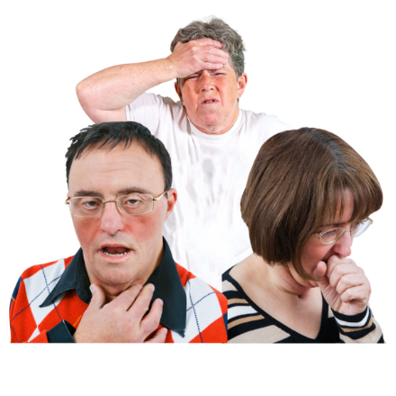
People with COVID-19 may:

- have a cough

- have a fever - this is when you
get really hot

- find it hard to breathe.
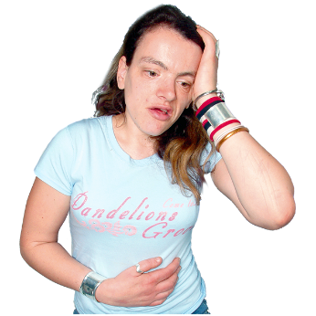

It is important to know that people who get a cold or flu may also have these things.

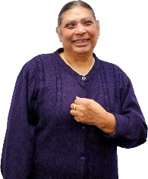
Some people with COVID-19 may not get sick.

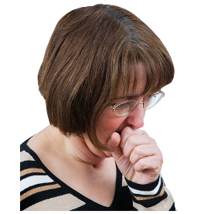
But they can still pass the virus to another person.

It can take up to 14 days from the time a person has been around someone with COVID-19 to when they get sick.
When a person has COVID-19 they can spread droplets onto things or people around them when they:

- cough

- sneeze
- talk

- touch other people like shaking hands
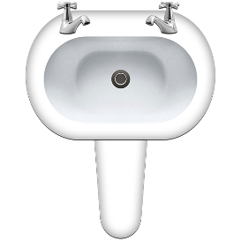
- touch surfaces or objects that someone else then touches

Droplets are very small bits of liquid that come out of a person’s nose or mouth.

The droplets could have the COVID-19 virus in them.

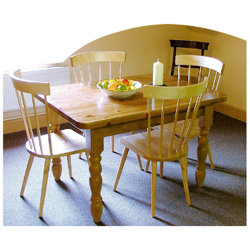
Surfaces and objects are things like:

- tables

- bathroom sinks

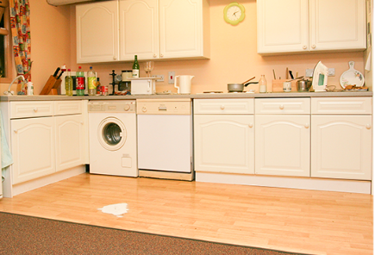
- kitchen benches

- door handles.

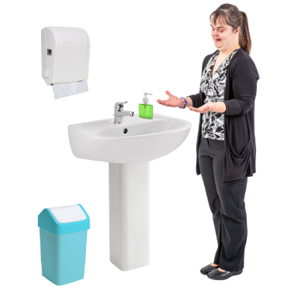
This factsheet will tell you what you can do to have less chance of getting COVID-19.

Things you can do to protect yourself and others from COVID-19

There are some important things that everyone can do to stop the spread of COVID-19.

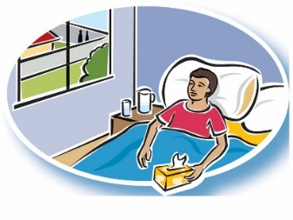
You should:

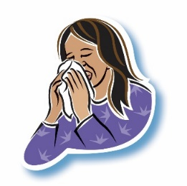
- stay away from people who are unwell with a cold or flu

- stay home if you feel unwell
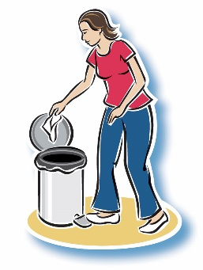
- cover your mouth and nose with a tissue when you cough or sneeze

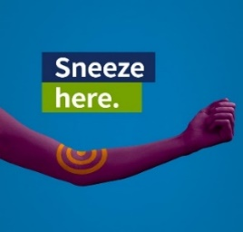
- throw away any tissues that you use

- cough or sneeze into your elbow if you have no tissues.
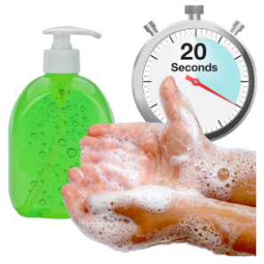
Make sure you wash your hands with soap and water for at least 20 seconds:

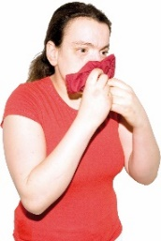
- after coughing or sneezing

- after blowing your nose
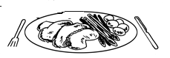

- before eating or touching food

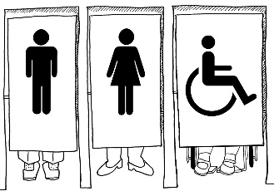
- after using the toilet

- after helping children wipe their
noses

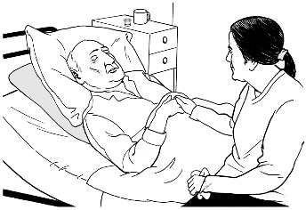
- after caring for sick people.

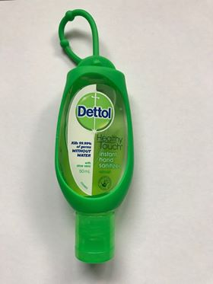
If there is no water or soap you can use hand sanitiser.

Another important thing you can do is try not to touch your:

- eyes

- nose

- mouth.

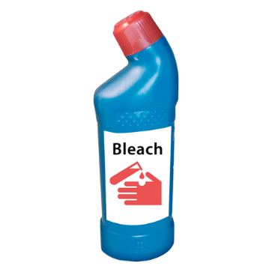
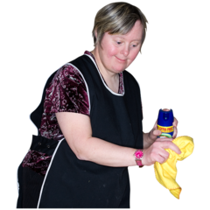

It is also a good idea to clean surfaces and objects that you use a lot.

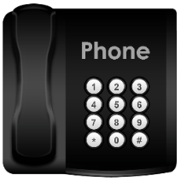
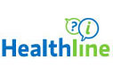
If you have any questions about COVID-19 you can call Healthline on:

0800 358 5453

It will not cost you any money to call Healthline.

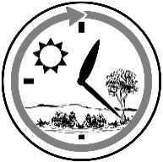
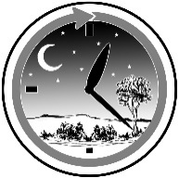
Healthline is open all the time – day and night.

Where to find more Easy Read
information about COVID-19

There are some more Easy Read factsheets called:

- COVID-19 information for people coming into New Zealand from overseas

- What to do if you think you have COVID-19

- COVID-19 and self-isolation.

You can find these Easy Read factsheets on the Ministry of Health website:
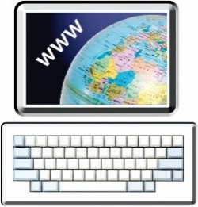
www.health.govt.nz/our-work/diseases-and-conditions/ covid-19-novel-coronavirus

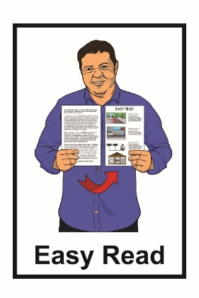
This information has been translated into Easy Read by the Make It Easy service of People First New Zealand Inc. Ngā Tāngata Tuatahi.

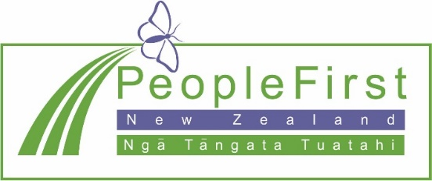
The ideas in this document are not the ideas of People First New Zealand Ngā Tāngata Tuatahi.

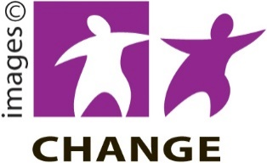
Make It Easy uses images from:
- Changepeople.org

- Photosymbols.com

- Sam Corliss

- Steve Bolton

