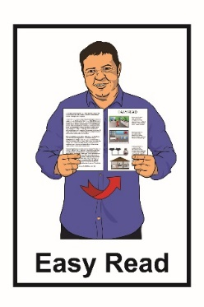

COVID-19 and self-isolation

16 March 2020 update

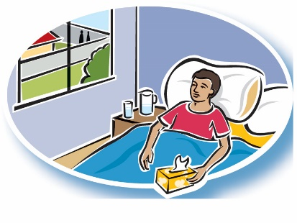
Self-isolation means not being in places for 14 days where you could give the COVID-19 virus to other people and staying at home.

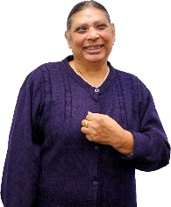
Some people with COVID-19 may not get sick.

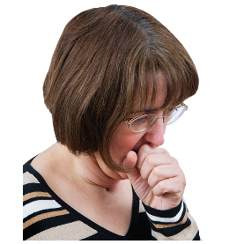
But they can still give the virus to other people.

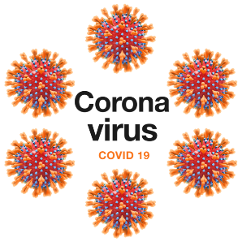
A virus is something that can make people sick.

It can take up to 14 days from the time a person has been around someone with COVID-19 to when they get sick.

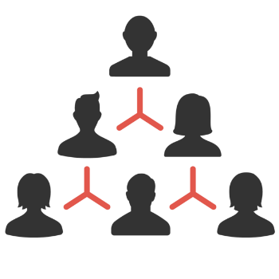
It is important to self-isolate so that the virus is not passed on to other people if you do get sick during this time.

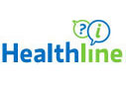

You need to call Healthline if you:
- are not sure if you should self-isolate

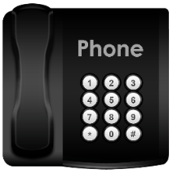
- decide to self-isolate.

The phone number Healthline is:
0800 358 5453
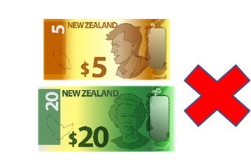

It will not cost you any money to call Healthline.

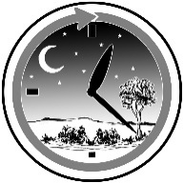
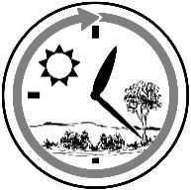
Healthline is open all the time – day and night.
Who needs to self-isolate?

You need to self-isolate if you:
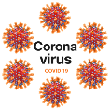
- have been tested and found to have COVID-19
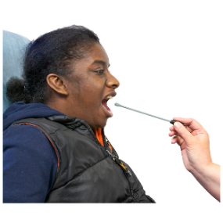
- have been tested for COVID-19 and waiting to find out your results

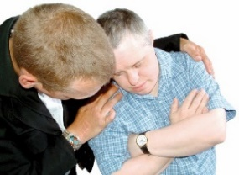
- have been in close contact in the last 14 days with someone who has been told they have COVID-19

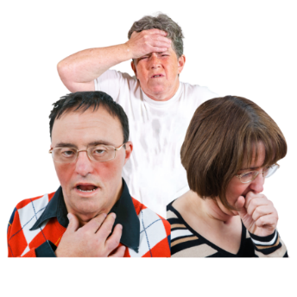
- if you feeling sick and you:

- have a cough

- have a fever – this is when you ger really hot

- are finding it hard to breathe.

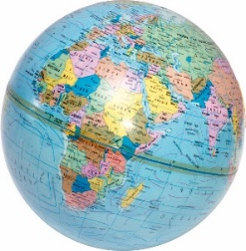
People coming into New Zealand from overseas also need to self-isolate for 14 days from the day they left the overseas country.

To find out more there is an Easy Read Factsheet called:

COVID-19 information for people coming into New Zealand from overseas.

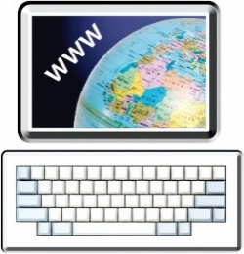
You can find this factsheet on the Ministry of Health website:

www.health.govt.nz/our-work/diseases-and-conditions/ covid-19-novel-coronavirus

What does self isolation mean?

Self-isolation means that you should try not to come into close contact with other people for 14 days.

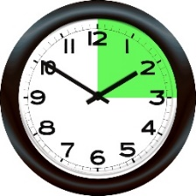
It means that during those 14 days you should try not to be within 2 metres of people for more than 15 mintues.

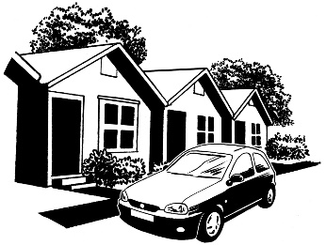
You will find self isolation easier to do if you:

- stay at home away from other people
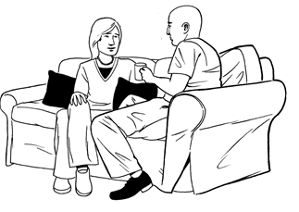

- do not have people come to visit you.

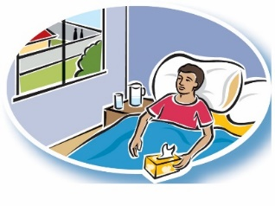
When you are in self-isolation do not go to:

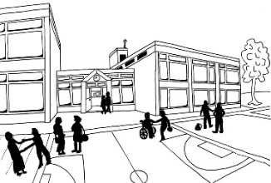
- your workplace

- school / university
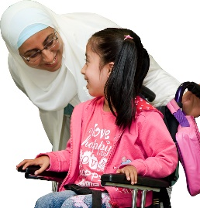

- childcare services

- church / faith-based activities

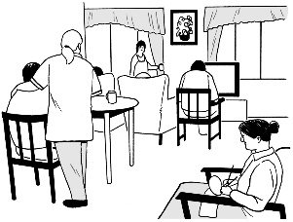
- rest homes or other places for older people

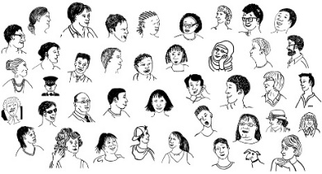
- restaurants

- places where there are lots of people.

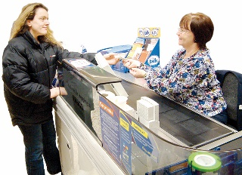
If you need food or medicine ask a family member or friend to:

- get food or medicine for you

- drop it off to you at your front door.

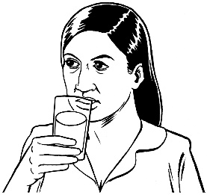
If you are living with other people you should not share things like:

- drinking cups or glasses

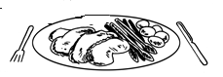
- things you eat with like plates or forks

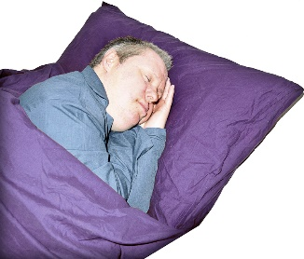
- towels

- pillows and sheets.

What you can do to stop the spread of
COVID-19

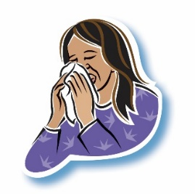
To stop COVID-19 from spreading:

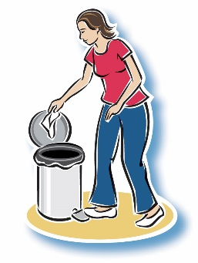
- cover your mouth and nose with a tissue when you cough or sneeze

- throw away any tissues that you use.
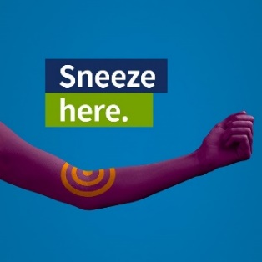

If you have no tissues then cough or sneeze into your elbow.

You should also:

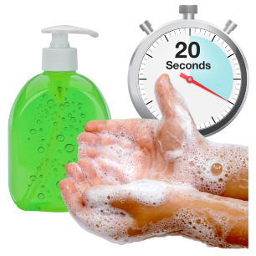
- wash your hands with soap and water for at least 20 seconds

- make sure you dry your hands well.
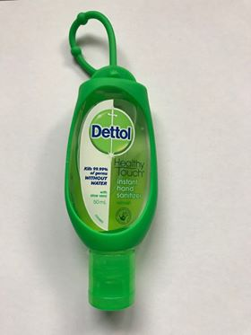
If there is no water or soap you can use hand sanitiser.

Try not to touch your:
- eyes

- nose

- mouth.

Taking care of you

During the 14 days that you are in self-isolation you may feel:

- stressed
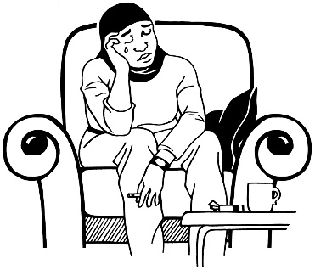
- lonely

- worried.

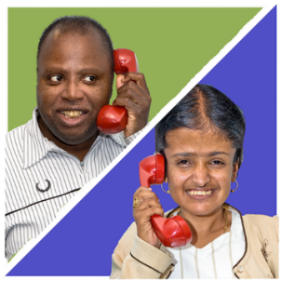
Some things you can do to look after yourself are:

- talk to your family or friends on the phone

- eat meals at normal times
- exercise at home

- go to bed at the same time each night.
If you are feeling stressed or lonely you can talk to someone at 1737: Need to talk:

Phone: 1737

Text: 1737

1737: Need to talk is a free service so it will not cost you any money.

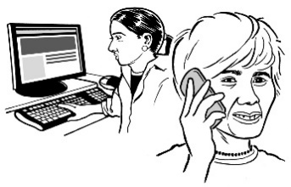
The 1737: Need to talk service is open all the time.

It is open all day and all night.

